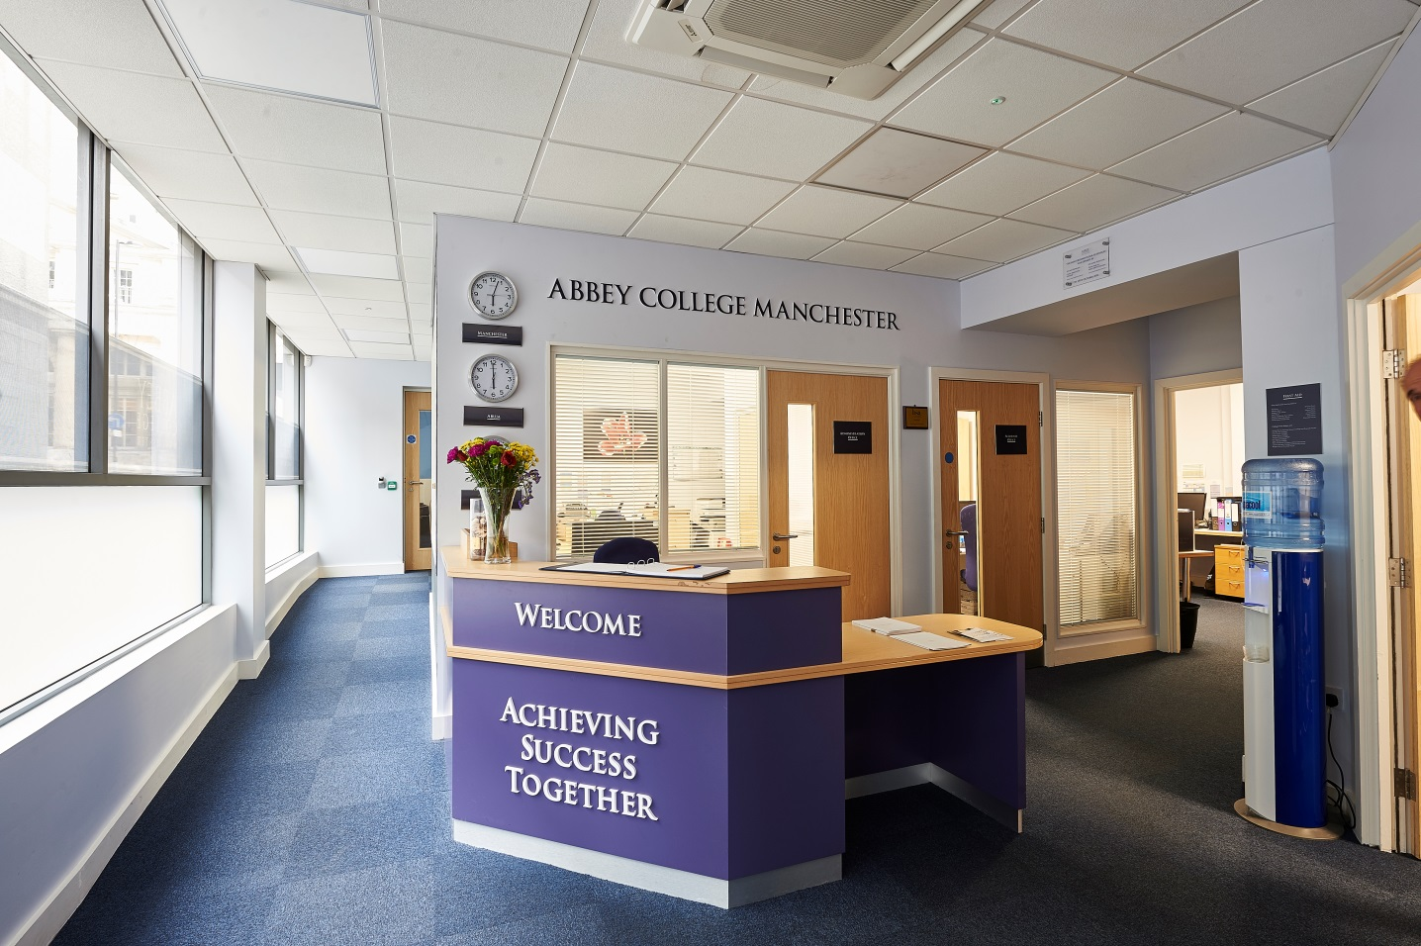

Information Pack:

SEND Coordinator

February 2019

About Abbey College Manchester

Abbey College Manchester was founded in 1990 and over the past twenty eight years has become one of the leading providers of independent sixth form education in Greater
Manchester. There are approximately 220 students in the college. Within this around 40% are from the Manchester area with the remainder coming from 25 different countries across Europe; Africa; Asia and the Americas.

We aim to:

• guide our students to achieve academic success and fulfil their aspirations
• respect and value each student providing a friendly, safe, supportive environment where students are happy and grow in confidence
• show a sensitive understanding of the challenges facing young people in the 21st Century by
empowering students to make informed decisions and have the determination to achieve their goals
• prepare our students for university, their future careers and to make a positive contribution to the community.

We are a dynamic, exciting college, situated in the heart of Manchester providing high quality, flexible A Level, International Foundation and GCSE programmes. We have recently introduced two unique programmes to complement our offering; these being the Combined Studies Programme and the Academic Studies with football Training Programme. Our modern building provides an environment conducive to study and in our small classes each student can develop their individual aptitudes aided by a strong system of tutorial guidance.

Teaching and learning is rigorous whilst being creative and responsive to individual need. Our enrichment activities include sport, voluntary work, charity events and many other opportunities led by the students and staff. We encourage students to raise their own expectations
and standards to the highest possible level. Staff, students and families get to know each other well and enjoy working together.

At Abbey College Manchester we offer a unique alternative to the traditional school whilst maintaining a strong academic ethos. Everyone contributes, everyone is appreciated; our committed teachers love their subjects and seek to inspire their students, in their turn, to love learning and value the acquisition of knowledge.

Learning support is a critical part of our provision as up to 25% of students require some adjustments in order that they can access their courses and achieve. The SEND Coordinator works closely with students and departments as well as the pastoral and students services team.

Department: Academic Support
Line manager: Assistant Principal Academic

The overarching role of the SENDCO is to identify and support students with learning needs and those with emotional needs which impact upon their academic studies. The SENDCO works as part of a team with pastoral, academic and support staff. The role is split into five broad areas as outlined below.

Student pastoral, academic support and mentoring
- Individual support sessions for students with SEND in agreed time frames
- Mentoring sessions for vulnerable and/or very anxious students.
- Provide feedback of assessment reports to students, parents and teachers
- Regular reviews throughout the year with students on the SEND lists
- Regular Sessions on mindfulness/stress management to tutor or year groups in conjunction with the college nurse

Teacher support
- Devise strategies to enable students to achieve and work with departments on delivering Reasonable Adjustments
- Identify via teachers and pastoral staff any anxious, vulnerable or student with unidentified learning difficulties
- Contribute to and run relevant staff CPD appertaining to SEND

Administration
- Collate and maintain files for students with SEND to include all the relevant documents and up to date reports during the run up to the new academic year and continue to update this as the year progresses
- Write and circulate Reasonable Adjustment (RA) documents to be formulated from relevant reports and discussion with students/parents
- Ensure Access Arrangements are on the exam board websites (JCQ Regulations)
- Compile and circulate lists of students to relevant staff including SEND, medical and vulnerable
- Ensure reasonable adjustments such as coloured paper, overlays, writing pens, Dictaphone, enlarged papers for exams/classwork are provided
- Write and review the department development plan and use student feedback to inform this

Co-ordination
- Identify, monitor, review progress of SEND students.
- Disseminate information to relevant teachers about students with SEND
- Liaise with the college nurse regarding vulnerable students or those with impacting medical conditions
- Liaise with the Examinations Officer to ensure the specific needs of students are met in mock and public exams
- Compile a list of those students requiring small room/own room/prompt/ rest breaks/extra time/laptops
- Invigilate/support students with specific exam requirements e.g. those requiring a reader, prompt or amanuensis
- Apply for special consideration following each exam series
- Annual Review meetings with students with EHC plans.
- Coordinate Assessments carried out by Dys-Appear for identified students
- Participate in Induction of new members of Staff – SEND documents and information

Outside connections
- Communicate regularly with parents regarding reports, assessments and previous interventions
- Attend meetings with parents and be involved in interviews with prospective students where relevant
- Liaise with previous schools/colleges about background information, previous support and relevant reports and paperwork
- Book assessments and assessors and disseminate the relevant information from the reports
- Liaise with Educational Psychologists as required
- Work with the Local Authority if required for a student on an EHC plan

Note: This job description is indicative of the duties and responsibilities of the post but does not form part of any contract of employment. All jobs within the college evolve over time and their features vary from year to year.

Person specification

1. Personal skills and qualities

- High levels of personal and professional integrity
- Commitment to academic excellence
- High degrees of self-confidence, personal energy and dynamism
- Personal warmth, good rapport with students, colleagues and parents
- Excellent organisational skills
- Appropriate levels of personal presentation
- Confident use of ICT
- Confident oral and written English skills
- Think creatively and imaginatively in response to new opportunities/challenges

2. Knowledge and experience

Qualifications
- Good academic achievement including A-levels
- A good honours degree and a PGCE
- SEND qualifications are desirable

Teaching
- Teaching experience at GCSE and A-level is highly desirable
- Experience of working with 14-19 year old students in a SENDCO capacity is essential
- Commitment to reasonable adjustments for those students requiring additional support
- Experience of supporting teachers in delivering reasonable adjustments

Philosophy and Ethos
- High expectations for student attainment, personal development and conduct
- Commitment to best practice in supporting students with SEND

Reporting to:

The Assistant Principal Academic

About the Alpha Plus Group

The Alpha Plus Group is the parent company of Abbey College Manchester and nineteen other schools. It was founded in 1931 under the name Davies, Laing and Dick. The schools and colleges within the group have developed a longstanding reputation for delivering premium quality education.

In all its educational establishments, the Alpha Plus Group aims to provide a supportive and controlled environment in which children and young people are encouraged to pursue high academic and personal goals as happy and secure individuals. The Group expects that all its staff will be alert to the needs of its pupils and students - including their need for safety and protection - and will put the interests of children and young people first at all times.

Each school and college retains its own identity, with the Heads and Principals afforded significant management authority, but with the benefits of financial security, camaraderie and opportunities for sharing best practice by belonging to one of the country's leading educational groups.

The selection process

Job title: SEND Coordinator

Activity | Date
Deadline for receipt of applications | Friday 22nd March
Shortlisting of candidates | w/c Monday 25th March
Interview dates | w/c Monday 31st March
Start date | 29th August 2019

Applications will only be accepted from candidates completing the Abbey College Manchester Application Form and Equal Opportunities Monitoring Form. These forms, together with a short covering letter explaining why you believe you are suitable for the role, should be addressed to the Principal and sent to: Abbey College Manchester, 5-7 Cheapside, off King Street, Manchester M2 4WG.

Safeguarding Statement
Candidates should be aware that all posts in the college involve responsibility for safeguarding children. The Abbey College Manchester Safeguarding Statement is as follows: “We recognise our moral and statutory responsibility to safeguard and promote the welfare of all students. We endeavour to provide a safe and welcoming environment where children and young people are respected and valued. We are alert to the signs of abuse and neglect and follow our procedures to ensure that children and young people receive effective support, protection and justice”.

Rehabilitation of Offenders Act, 1974
This post is exempt from the Rehabilitation of Offenders Act 1974 and therefore all convictions, cautions and bind-overs, including those regarded as ‘spent’ must be declared. Please provide full details in a sealed envelope marked ‘Confidential’. The letter will be opened after shortlisting, prior to interview.

References
These will be taken up after interview. As part of this your referees will be asked about your suitability to work with children and whether they know of any disciplinary offences relating to children or young persons (whether the disciplinary sanction is current or time expired) and whether you have been the subject of any child protection allegations or concerns and if so the outcome of any enquiry or disciplinary procedure.

Interview
If you are invited to attend an interview this will be conducted in person and will include questioning on your suitability to work with children. All candidates must bring original documents confirming any educational and professional qualifications that are necessary or relevant for the post (e.g. the original or certified copy of certificates, diplomas, etc.). All candidates invited to interview must also bring their passport or photo ID and proof of the right to work in the UK (if applicable).

Terms and conditions

Remuneration
- The starting salary is dependent on qualifications, knowledge and experience as outlined in the job description.

Hours of work
- The post is up to 0.8 and would be spread over four days. This is open to negotiation. The standard college opening hours are 8am to 6pm. Normal working hours are 8.30am to 4.30pm.

Holidays
- All college holidays.

Pension provision
Abbey College Manchester is part of the Alpha Plus Group and automatically enrol all new employees (unless requested not to by the employee) onto the company pension scheme. Notification of the pension plan (and all further details including opt out / opt in rights) will be provided.

Offer of appointment
Any offer of appointment is conditional on receipt of satisfactory references, an enhanced DBS clearance, the interrogation of qualifications and proof of the right to work in the UK.

We are committed to safeguarding and promoting the welfare of children and young people.

We expect all staff to share this commitment and to undergo appropriate checks, including enhanced DBS checks.

