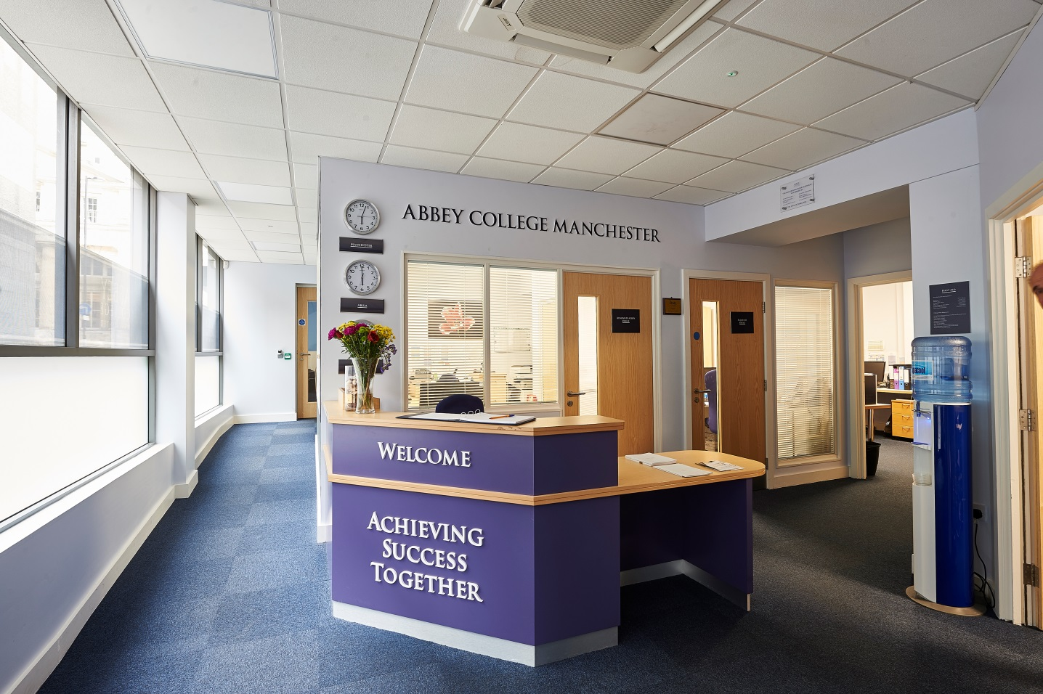

Information Pack:

Assistant Principal Pastoral and Boarding

February 2019

About Abbey College Manchester

Abbey College Manchester was founded in 1990 and over the past twenty eight years has become one of the leading providers of independent sixth form education in Greater
Manchester. There are approximately 220 students in the college. Within this around 40% are from the Manchester area with the remainder coming from 25 different countries across Europe; Africa; Asia and the Americas.

We aim to:

• guide our students to achieve academic success and fulfil their aspirations
• respect and value each student providing a friendly, safe, supportive environment where students are happy and grow in confidence
• show a sensitive understanding of the challenges facing young people in the 21st Century by
empowering students to make informed decisions and have the determination to achieve their goals
• prepare our students for university, their future careers and to make a positive contribution to the community.

We are a dynamic, exciting college, situated in the heart of Manchester providing high quality, flexible A Level, International Foundation and GCSE programmes. We have recently introduced two unique programmes to complement our offering; these being the Combined Studies Programme and the Academic Studies with football Training Programme. Our modern building provides an environment conducive to study and in our small classes each student can develop their individual aptitudes aided by a strong system of tutorial guidance.

Teaching and learning is rigorous whilst being creative and responsive to individual need. Our enrichment activities include sport, voluntary work, charity events and many other opportunities led by the students and staff. We encourage students to raise their own expectations
and standards to the highest possible level. Staff, students and families get to know each other well and enjoy working together.

At Abbey College Manchester we offer a unique alternative to the traditional school whilst maintaining a strong academic ethos. Everyone contributes, everyone is appreciated; our committed teachers love their subjects and seek to inspire their students, in their turn, to love learning and value the acquisition of knowledge.

Assistant Principal Pastoral and Boarding

This position is one of four posts on the SLT which comprises the Principal, the Assistant Principal Academic and the Assistant Principal Operations who work closely as a team sharing ideas and striving to achieve the best outcome for every student and colleague. The team have an overview of the whole college and together form and implement the college ethos and vision meeting weekly as well as informally and individually.

The Assistant Principal Pastoral and Boarding has an overarching role in leading safeguarding, pastoral welfare and boarding in the college. The post holder will be an experienced teacher and pastoral senior leader with direct experience of working in a boarding environment. Whilst the role is related to student welfare and personal development as well as compliance linked to boarding and safeguarding, the successful candidate will have a strong academic ethos and will ensure there is focus on ensuring students reach their potential from their given starting point. An important part of the role incudes supporting Heads of Year in liaising with parents and agents regarding student progress. At the college we favour an individualised and personalised approach to working with each student and we are looking for someone who shares in that belief.

The post holder will be line managed by the Principal and in turn will line manage the Heads of Year, the Head of Senior Boarding and the college nurse. Several posts including the Director of Accommodation and SENCO will have shared line management with the other members of the SLT regarding different aspects of their roles.

The key aspects of the role are as follows (although the list is not exhaustive and the role is likely to evolve over time).

SLT

- To take the lead in reviewing the policies related to pastoral, boarding and safeguarding and discuss revisions with appropriate staff
- To design whole staff CPD related to safeguarding, boarding and pastoral care in conjunction with the SLT and other appropriate staff
- Work with the Principal and other colleagues to have an oversight of the student welfare sections of the college SEF are up to date and accurate,
- Participate in appointments of relevant staff in the college and in boarding.
- To interview prospective students both in person or by telephone and in liaison with the Principal to recommend suitable academic programmes
- Strive to promote good relations with the wider community and the College neighbours dealing with general complaints e.g. from businesses, community officers or members of the public.

Safeguarding

- To be the Designated Safeguarding Lead for the College, advising the Principal and working with the DDSL Team (see detailed description of this part of the role attached)
- Manage the ‘My Concern’ reporting system and ensure it is used effectively.
- Ensuring all new staff are inducted in the pastoral aspects of the college and the training of all pastoral staff including the nurses in First Aid, Health and Safety, Child Protection and Mental Well-Being.
- Liaise with the College Nurses as required on family issues and health and welfare.

Boarding

- Work with the Director of Accommodation and the Heads of Year to ensure that all students in homestay are happy and integrated with their families.
- To review with the Director Accommodation and the Head of Senior Boarding the allocation of students to homestays and to Riverside
- With the Director of Accommodation and Head of Senior Boarding review the Homestay and Houseparents handbooks
- In conjunction with the Head of Senior Boarding and the Director of Accommodation ensure NMS for boarding are adhered to and met.
- Provide leadership of the Intermediate Boarding Compliance Inspection and the boarding/pastoral aspects of the Integrated Inspection.
- To be on call as part of the SLT rota as allocated for Riverside House and homestay emergencies in the evening, at weekends and during college holidays when the residence is open.
- Attend, when appropriate, meetings with Host Family and Houseparents.

Pastoral – Working with the Heads of Year

- To co-ordinate aspects of the Head of Year activities appertaining to student management and day to day organisation; to oversee the Heads of Year meetings and meet regularly with each individual Head of Year to review the progress of the students and discuss solutions to pastoral or academic problems.
- Oversee college attendance working with Tutors, Heads of Year, Boarding staff and Academic Services to maximise attendance and ensure that appropriate and consistent sanctions are applied where necessary.
- To contribute to creating calm, purposeful and harmonious atmosphere in the college and ensuring that any issues linked to bullying or cyber-bullying are dealt with swiftly and logged.
- To monitor student behaviour in the college, manage any disciplinary incidents with the assistance of the Heads of Year and to ensure that any issues are dealt with efficiently and consistently.
- Produce and oversee the college duty rota including breaks and punctuality rule.
- To liaise with Heads of Year to develop the student voice and other opportunities (e.g. peer support) in the college
- To ensure, in liaison with Heads of Year, any statutory PHSE content is delivered to students.
- Foster a sense of community in the college at the start of each academic year and to take part in assemblies when appropriate.
- To work with Heads of Year, parents and agents to promote a culture ‘no surprises’ when it comes to reporting on academic performance.
- Facilitate the organisation of college events including The Festive Evening and The College Graduation ceremony.

The role and responsibilities of the Designated Safeguarding Lead (DSL)

The DSL takes lead responsibility for safeguarding and child protection (including online safety). It is apparent from the procedures outlined throughout this policy that great reliance is placed upon all staff sharing information and referring their concerns to the DSL. This, in turn, puts great reliance on the DSL to carry out their role thoroughly and diligently.

As a member of the Senior Leadership Team, the DSL must ensure they have appropriate status, authority, time, funding, training, resources and support to fulfil their responsibilities. They must consult the Principal, and if necessary the nominated governor, if they feel that this is not the case. There must always be cover for the DSL role, in the form of a Deputy DSL, who must be trained to the same level as the DSL. Though activities may be delegated to the Deputy DSL, the ultimate responsibility remains with the DSL.

The duties and objectives of the DSL include:
- providing advice and support to staff on child welfare and child protection matters
- taking lead responsibility for online safety, including supporting pupils with SEND to stay safe online
- gathering and collating information on alleged safeguarding incidents, seeking clarification from alleged perpetrators or victims
- managing the referral process (see more below)
- keeping parents informed (wherever possible and if appropriate) and sharing with them any reports concerning their child
- keeping the Principal informed of all significant safeguarding matters
- understanding relevant data protection legislation and regulations, especially the Data Protection Act 2018 and the General Data Protection Regulation
- undergoing their own training updates (see more below)
- liaising with designated officers at the local authority and other local agencies in line with Working Together to Safeguard Children
- consulting on the design of the PSHEE policy and relevant curriculum components of welfare and safeguarding.
- for ‘looked after’ children, ensuring that appropriate staff have relevant information about care needs and contact arrangements. Staff should also be aware of previously looked-after children and have the skills, knowledge and understanding to provide support.
- raising awareness of safeguarding matters generally (see more below)
- in conjunction with the governors, ensure the safeguarding policy is reviewed annually for effectiveness and for compliance with latest legislation, or updated sooner where necessary

Salaried staff may be asked from time to time by the Principal to carry out additional duties that allow for the smooth running of the college.

Note: This job description is indicative of the duties and responsibilities of the post but does not form part of any contract of employment. All jobs within the college evolve over time and their features vary from year to year.

Person specification

1. Personal skills and qualities

- High levels of personal and professional integrity
- Commitment to academic excellence
- High degrees of self-confidence, personal energy and dynamism
- Personal warmth, good rapport with students, colleagues and parents
- Excellent organisational skills
- Appropriate levels of personal presentation
- Confident use of ICT
- Confident oral and written English skills
- Think creatively and imaginatively in response to new opportunities/challenges
- Have experience of, and a strong interest in, the active recruitment of students

2. Knowledge and experience

Qualifications
- Good academic achievement including A-levels or equivalent in the teaching subject
- A good honours degree and a PGCE
- DSL trained

Pastoral experience
- Experience of working in a boarding school with responsibilities linked to boarding
- Experience of pastoral roles such as a Head of Year/ Head of House/ Head of Sixth Form
- Experience of leading a pastoral team

Teaching and Learning
- Experience of teaching GCSE and A-level
- Evidence of creative and innovative approach to teaching and learning
- Commitment to improving, monitoring and evaluating teaching and learning
- Commitment to assessment for learning
- Commitment to reasonable adjustments for those students requiring additional support
- Ability to teach at the pace to deliver a GCSE course in one year
- Ability to adapt teaching style to accommodate the needs of students whose second language is English.

Philosophy and Ethos
- High expectations for student attainment, personal development and conduct
- Commitment to delivering the curriculum for students of a range of abilities and with a range of English levels
- Commitment to best practice in pastoral support and student welfare

Reporting to:

The Principal

About the Alpha Plus Group

The Alpha Plus Group is the parent company of Abbey College Manchester and nineteen other schools. It was founded in 1931 under the name Davies, Laing and Dick. The schools and colleges within the group have developed a longstanding reputation for delivering premium quality education.

In all its educational establishments, the Alpha Plus Group aims to provide a supportive and controlled environment in which children and young people are encouraged to pursue high academic and personal goals as happy and secure individuals. The Group expects that all its staff will be alert to the needs of its pupils and students - including their need for safety and protection - and will put the interests of children and young people first at all times.

Each school and college retains its own identity, with the Heads and Principals afforded significant management authority, but with the benefits of financial security, camaraderie and opportunities for sharing best practice by belonging to one of the country's leading educational groups.

The selection process

Job title: Assistant Principal Pastoral and Boarding

Activity | Date
Deadline for receipt of applications | 22nd February 2019
Shortlisting of candidates | w/c 25th February 2019
Interview dates | 4th and 5th March 2019
Start date | 29th August 2019

Applications will only be accepted from candidates completing the Abbey College Manchester Application Form and Equal Opportunities Monitoring Form. These forms, together with a short covering letter explaining why you believe you are suitable for the role, should be addressed to the Principal and sent to: Abbey College Manchester, 5-7 Cheapside, off King Street, Manchester M2 4WG.

Safeguarding Statement
Candidates should be aware that all posts in the college involve responsibility for safeguarding children. The Abbey College Manchester Safeguarding Statement is as follows: “We recognise our moral and statutory responsibility to safeguard and promote the welfare of all students. We endeavour to provide a safe and welcoming environment where children and young people are respected and valued. We are alert to the signs of abuse and neglect and follow our procedures to ensure that children and young people receive effective support, protection and justice”.

Rehabilitation of Offenders Act, 1974
This post is exempt from the Rehabilitation of Offenders Act 1974 and therefore all convictions, cautions and bind-overs, including those regarded as ‘spent’ must be declared. Please provide full details in a sealed envelope marked ‘Confidential’. The letter will be opened after shortlisting, prior to interview.

References
These will be taken up after interview. As part of this your referees will be asked about your suitability to work with children and whether they know of any disciplinary offences relating to children or young persons (whether the disciplinary sanction is current or time expired) and whether you have been the subject of any child protection allegations or concerns and if so the outcome of any enquiry or disciplinary procedure.

Interview
If you are invited to attend an interview this will be conducted in person and will include questioning on your suitability to work with children. All candidates must bring original documents confirming any educational and professional qualifications that are necessary or relevant for the post (e.g. the original or certified copy of certificates, diplomas, etc.). All candidates invited to interview must also bring their passport or photo ID and proof of the right to work in the UK (if applicable).

Terms and conditions

Remuneration
- The starting salary is dependent on qualifications, knowledge and experience as outlined in the job description.

Hours of work
- The post is full time and the standard college opening hours are 8am to 6pm. The post holder would be expected to stay until the end of twilight (6pm) on a Monday and Tuesday.

Holidays
- All college holidays apart from the August recruitment period (from 12th August in 2019). The post holder would be expected to come into college in the holidays if there was a need and to visit the residence out of college hours if there were an emergency. As DSL the post holder would be need to be contactable whilst the college is in session and in a rotation with other deputy DSLs.

Pension provision
Abbey College Manchester is part of the Alpha Plus Group and automatically enrol all new employees (unless requested not to by the employee) onto the company pension scheme. Notification of the pension plan (and all further details including opt out / opt in rights) will be provided.

Offer of appointment
Any offer of appointment is conditional on receipt of satisfactory references, an enhanced DBS clearance, the interrogation of qualifications and proof of the right to work in the UK.

We are committed to safeguarding and promoting the welfare of children and young people.

We expect all staff to share this commitment and to undergo appropriate checks, including enhanced DBS checks.

